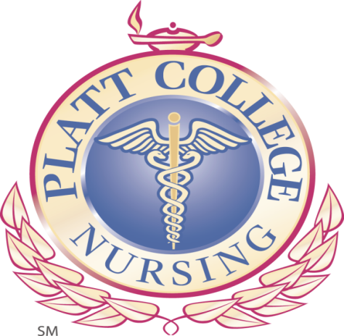

To whom it may concern:
I would like to recommend (student name removed) as a candidate for a position with your organization. In her position as nursing student, (student name removed) was a (Month/Year) graduate from our LPN to RN program at Platt College.
(student name removed) was an exceptional nursing student and a leader among her peers. She is very self-motivated, determined, and goal-oriented in regard to her academic and professional objectives. She has excellent written and verbal communication skills, is extremely organized, can work independently, and is able to effectively multi-task to ensure that all theory, clinical assignments and coursework are completed in a timely manner and according to curriculum expectations.
(student name removed) was always willing to offer her assistance and had an excellent rapport with the student body, faculty, and clinical facilities. She would be an asset to any employer and I recommend her for any endeavor she chooses to pursue.
Yours truly,

Crystal Jensen, BSN, RN
Nursing Instructor
Platt College
3801 S. Sheridan
Tulsa, OK 74145
918-663-9000 (ext. 69)

